**ASSIGNMENT 4.2**

**on**

**Asynchronous messaging and Kafka**

**Submitted by:**

**Haseebullah Shaikh (2303.KHI.DEG.015)**

**and**

**Faiza Gulzar Ahmed (2303.khi.deg.001)**

**Dated: 8**th May 2023

**Task 01 :**

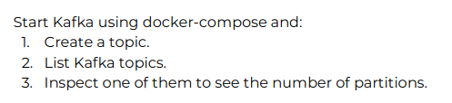

1. **Creating topic**

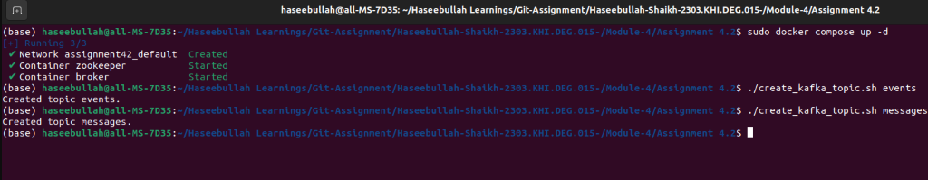

1. **Listing Kafka topics**



1. **Inspecting partitions in each topic**

